NASA Flight Opportunities Program
Internal Payload Request Process
October 2016

Call Opens: Oct 3, 2016
Proposals Due: Oct 31, 2016
Notifications to Proposers: Nov 30, 2016 (Target)

Section 1 – Purpose
The purpose of this document is to explain the criteria used to accept technology payloads for flight demonstration in relevant space environments on Flight Opportunities program (“program”) provided flight platforms.
Section 2 – Scope
The Flight Opportunities program provides flights for NASA developed payloads to mature cross-cutting technology beyond TRL 4. The program may provide up to $50K to support preparation and development of the payload for flight. The program does not provide funding for technology development. Proposals that do not involve cross-cutting technology are encouraged to apply provided that the necessary cost-sharing can be arranged – see Section 6 below.
Section 3 – Eligibility
The NASA Internal Payload request process is applicable to NASA internal and funded technology development activities seeking maturation advancement from Technology Readiness Level (TRL) 4.
If you are a non-NASA entity and have an active agreement with NASA to perform work related to your proposal, you may be eligible for this call. – please contact the Flight Opportunities program for more information at NASA-FlightOpportunities@mail.nasa.gov.
Section 4 – General Info
Requests (and supporting documentation as required) are to be submitted to the Flight Opportunities program at NASA-FlightOpportunities@mail.nasa.gov.
The Flight Opportunities program (“program”) within the NASA Space Technology Mission Directorate (STMD) strategically invests in the growth of the commercial spaceflight market while helping advance technologies that will enable future space missions for science and exploration. The program achieves these self-reinforcing objectives by selecting promising technologies from industry, academia, and government to test on suborbital launch vehicles, reduced gravity aircraft and high altitude balloon flights. Investment in tests that take technologies from the laboratory to a relevant flight environment facilitates technology maturation, validates feasibility, and reduces technical risks. These investments enable infusion of key space technologies into multiple future space missions.
If the TRL of a technology being developed by a NASA or other government program can be advanced through a flight demonstration on a suborbital launch vehicle or high altitude balloon, a NASA Internal Payload Request may be submitted to the Flight Opportunities program.
Note: Parabolic aircraft flights for NASA Internal payloads may be available under this program – contact Flight Opportunities for more details.
Section 5 – Flights and Funding Provided by the Flight Opportunities Program
The program will provide one or more flights from one of the flight providers currently on contract with the Flight Opportunities program:
sRLV | Blue Origin | https://www.blueorigin.com
 | UP Aerospace | http://www.upaerospace.com
 | Virgin Galactic | http://www.virgingalactic.com
VTVL | Masten Space Systems | http://masten.aero
Balloon | Near Space Corporation | http://nsc.aero
 | World View | http://worldview.space
Flights for parabolic aircraft may be available under this program – contact Flight Opportunities for more detail.
Up to $50K of procurement funding may be provided to support preparation and development of the payload for flight. Preparation and development for flight can include generation of Payload Requirement Document, Test Readiness Review, participation in integration meetings, and flight test support. These funds cannot be used for Civil Service labor or Civil Service travel.
Section 6 – Cost Sharing and Flight Cost
In general, requesters seeking to fly a technology that is outside the scope of STMD will be expected to enter into a cost reimbursement or cost sharing agreement for flight testing.
Proposals that do not have a cross-cutting STMD technology value may be submitted, provided that the PI’s submitting organization provides full funding for the flight(s). This mechanism is used for cases where it is in the best interest of the government to have the Flight Opportunities program direct the flight activities rather than require the proposing entity to develop a process and contract for the flights on their own.
A flight cost analysis will be performed by the program to determine the overall cost which may include non-standard services from the flight provider. The program will make a determination if sufficient resources are available to provide one or more flight(s).
Cost-sharing/matching from other STMD, NASA Mission Directorates, or Other Government Agencies is encouraged and will improve the ranking for flight.
Section 6 – Required Information
The completed NASA Internal Payload Request Form is required.
For technologies that have gone through a prior/previous competitive selection process, the request package should include the original proposal if possible, for example SBIR/STTR, CIF.
If the technology has not gone through a prior competitive selection process, a letter of affirmation from the relevant NASA Mission Directorate is required.
Requesters from STMD programs (SBIR/GCD/CIF, etc.) do not need to re-justify their relevance to space technology investment priorities, but may be asked to provide letters of affirmation from Principle Technologists, Center Chief Technologist, or other entity, depending on the amount of original development funding provided by NASA.
Section 7 – Evaluation Factors
Requests will be evaluated based on the following factors:
NASA Support:
Flight requesters are encouraged to obtain letters of affirmation from a NASA Mission Directorate, i.e. Principle Technologists, Center Chief Technologist, etc., explicitly endorsing the value of the technology and payload flight. For payloads that have not been previously competitively selected, letters of affirmation are required.
Relevance to U.S. Space Exploration and Utilization: (non-STMD requests only)
Technologies proposed for testing must be in alignment with strategic investment guidance such as the NASA Strategic Space Technology Investment Plan, the National Research Council prioritizations of the NASA Space Technology Roadmaps, or STMD Strategic Thrust Areas such as Mars Entry, Descent, and Landing Systems. Requests from outside STMD will also be evaluated to ensure that STMD involvement in the proposed testing is appropriate and logical. Proposals that do not have a cross-cutting technology value may be submitted, provided that the submitting organization provides full funding for the flight(s) – see Cost Sharing above.
Comparison to State of the Art and Requirement for Flight
The space technology must be revolutionary, disruptive, or transformational, representing a mission enabling capability or a substantial performance improvement relative to the current state of the art. A compelling case must be made for flying the payload in lieu of conducting the experiment using more affordable means (i.e., ground testing).
Past Performance:
The NASA program manager or technical monitor from the program that initially selected the technology may be asked to evaluate the development team’s performance under that effort to ensure that further investment is prudent. Performance from any previous flight test or technology development activities with the program may also be considered. Unsuccessful technology demonstrations are not unexpected and do not necessarily constitute poor past performance provided that the activities were well managed.
Section 8 – Internal Payload Process
Before submitting a proposal, it is usually beneficial to contact the program to find out more about the flight environments available and how best to prepare the proposal. Once per quarterly call cycle, proposals are brought forward to STMD for concurrence. Prior to the STMD-level review, inadequate proposals may be re-worked to address deficiencies. The total duration of the process from the initial opening of the call to the notifications is approximately 2-3 months.

NASA Flight Opportunities Program
Internal Payload Request Form
Part 1 - General Information

Activity Title
Provide full title of the payload experiment
Summary of Key Information
Principle Investigator/Title/NASA Center or Organization:
Co-Investigator/Title/NASA Center or Organization (if applicable):
Collaborator/Title/NASA Center or Organization (if applicable):
NASA Cognizant Official Name/Title/NASA Center/Organization:
Identify the NASA cognizant official supporting this flight request. (This is likely the Program/Project Manager or Technical Monitor for the NASA activity identified above, but could also be a Center Chief Technologist, Center Chief Scientist, etc.) For payloads that have not been competitively selected, letters of affirmation are required.
Grants or Other Funding Sources:
PI E-mail:
PI Phone:
Cost Sharing: Provide amount of cost sharing being provided by the proposer.
Payload Preparation Support Funding
If requesting funding for payload development and preparation for flight, provide amount requested (up to $50K) and breakdown of costs.
Program/Project
Identify the program or project that selected your technology for development or selected your proposal for a mission/activity that includes the technology to be flight tested.
Summary (Abstract)
(Limit 500 words)
Summary Chart
Provide a Summary Chart as shown in the figure below.
The purpose of the Summary Chart is to capture the top-level, critical information into a single, stand-alone page. The Summary Chart will be used for NASA internal presentations and may also be released publically if the proposal is selected. Proprietary and/or ITAR information must not be included and all information on the chart must be publically releasable by NASA. The Summary Chart may be edited for formatting and uniformity by FO.
The Summary Chart shall use the PowerPoint format as provided in the figure. The titles and layout of each block must not be changed. The size of each text block may be adjusted as needed. The text in each block may be provided in sentence or "bulletized" format. A minimum text size of 10 point is required. The specific instructions for content in each block are shown below.
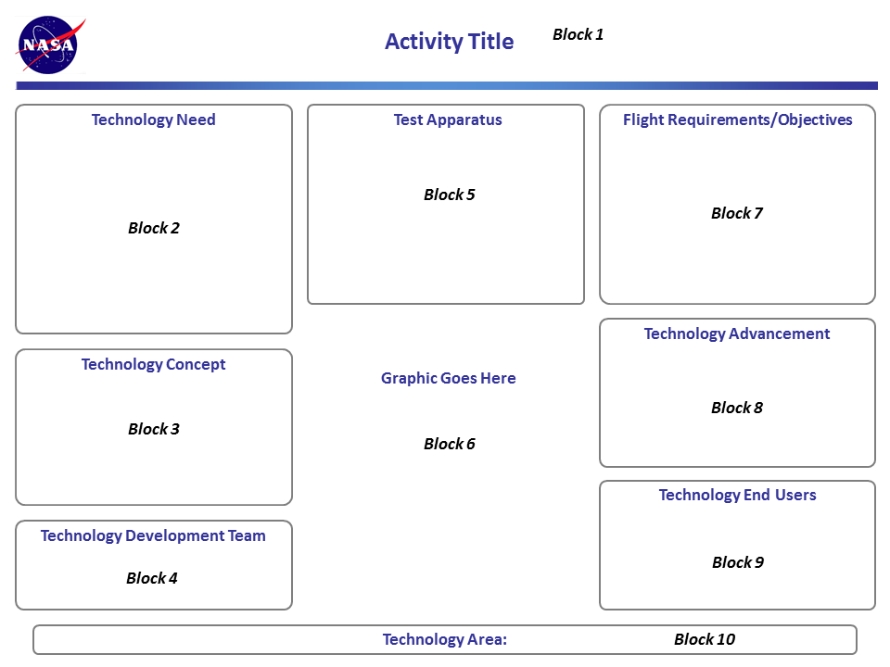

Block 1 - Activity Title
Provide the title exactly as provided in the first part of the request form under Activity Title.

Block 2 - Technology Need
Describe the current state of the art and need(s) for advancement. A statement as to the technology relevance and how the proposed technology will advance the state of the art should be included.
Block 3 - Technology Concept
Describe the overall concept of the proposed technology and its purpose. This should not include proprietary information.
Block 4 - Technology Development Team
Provide the name and the organizational title of the Principal Investigator, Co-Investigators, NASA Cognizant Official, and Collaborators. Provide the name of the submitting organization.
Block 5 - Test Apparatus
Provide a brief description of the actual payload flight apparatus. This should include the overall size and weight as well as any special interface and operational requirements. Special hazards or safety issues should be identified.
Block 6 - Graphic
A photo and/or a functional schematic of the technology must be provided.
Block 7 - Flight Requirements/Objectives
Outline the overall flight test plan and identify the type of flight profile and number of flights required. The specific technical objectives for each flight as well as the number of flight personnel and any special flight requirements should be defined. The flight readiness date should be included.
Block 8 - Technology Advancement
Include specific statements as to exactly how a successful flight test program will advance the state of the art. Identify the anticipated Technology Readiness Level following completion of the flight program.
Block 9 - Technology End Users
Identify users and applications of the proposed technology once it has been sufficiently developed. This could include NASA and other government flight programs as well as commercial flight and Earth applications.
Block 10 - Technology Area
Provide the primary NASA Technology Area addressed by your technology to the 3rd level, i.e. 4.3.3.
Relevance to U.S. Space Exploration and Utilization: (non-STMD requests only)
Technologies proposed for testing must be in alignment with strategic investment guidance such as the NASA Strategic Space Technology Investment Plan, the National Research Council prioritizations of the NASA Space Technology Roadmaps, or STMD Strategic Thrust Areas such as Mars Entry, Descent, and Landing Systems. Identify the specific 2015 Technology Road Map Area (to the 3rd level), Strategic Technology Investment Plan Section, Space Technology Focus Area, Decadal Survey/NRC Recommendation, Design Reference Mission, Exploration Road Map, etc. that is being addressed.
Requests from outside STMD will also be evaluated to ensure that STMD involvement in the proposed testing is appropriate.
(Limit 100 words)
Comparison to State of the Art and Requirement for Flight
Describe the capability being addressed, the current state of the art, and top technical issues associated with achieving the needed capability. Describe the extent to which the proposed effort involves a revolutionary, disruptive, or transformational space technology that represents a mission enabling capability or a substantial performance improvement relative to the current state of the art. Provide a compelling case for flying the payload in lieu of conducting the experiment using more affordable means (i.e., ground testing).
(Limit 500 words)
Technology Readiness Level (TRL)
Provide the TRL of the technology with respect to the planned operational environment using the TRL scale as articulated in the NPR 7123.1B Appendix E.
Current:
Anticipated After Flight Demonstration:
Flight Window
Indicate the earliest date in which the payload would be ready for flight and identify the required test completion date, if applicable.

NASA Flight Opportunities
Internal Payload Flight Request Form
Part 2 – Flight-Specific Information

Flight Profile and Number of Flights
Identify the requested flight profile from the available categories and identify the associated relevant environment being targeted. Indicate the minimum number of flights and the likely number of flights required to achieve the test objectives.
Note - Some flight regimes are supported by more than one flight provider on contract. Therefore, it is imperative that no commitments are made to any flight providers by proposers. It is the responsibility of FO to negotiate the actual flights including costs for standard and non-standard services. An FO campaign manager will work with the PI to determine the most suitable vehicle for the test.
Options:
80+km
80+km with payload ejection at apogee
30+km with specific flight profile (describe)
30+km long duration (specify duration)
30+km with payload release at apogee
Open-loop controlled powered landing (describe)
Closed-loop controlled powered landing (describe)
Payload Dimensions, Mass, and Power
Identify actual or estimated payload dimensions and mass. If the payload consists of multiple standalone modules please identify the size and mass for each module. Identify any payload power requirements to be provided by the vehicle or external source.
Potential Hazards or Interferences
Identify any potential hazards or systems that may interfere with other payloads. Provide a brief description of any hazard/interference identified.
Flammable Materials
Pyrotechnics/Explosives
Frangible Materials/Stored Mechanical Energy
Toxic/Carcinogenic Materials
Corrosive Materials
Pressure Systems
Off-gassing
Lasers
Radio Frequency Emissions
Ionizing Radiation
Extreme Hot/Cold Temperatures
High Voltages
Vibration (incl. Acoustic)
Biological Materials
Other
Additional Vehicle, Range and Ground Support Requirements
Identify any additional requirements for payload accommodation, telemetry and range support, and pre/post flight operations. Provide a brief description of any requirement identified.
External Venting
Payload Access to the External Environment
Optical Ports
In-Flight Telemetry or Payload Communication
Payload Triggering Signal/Crew Interaction
Day of Flight Activation/Calibration/Servicing
Time Sensitive Pre/Post Flight Payload Access
Vehicle Flight Data (for post-flight analysis)
Other

Images of the Technology Payload
Attach an image(s) that depict the test apparatus, technology hardware, specific technology features, and if applicable, concept of operations.
Original Proposal and Letter of Affirmation (Non-STMD Requests Only)
Payload requesters are encouraged to obtain letters of affirmation from a NASA Mission Directorate. For payloads that have not been competitively selected, letters of affirmation are required.
Payload requestors are also encouraged to attach the original proposal submitted to the Mission Directorate that is funding the development activity if possible.

