This PHM Data Challenge is focused on fault detection and magnitude estimation for a generic gearbox using accelerometer data and information about bearing geometry. Scoring is based on the ability to correctly identify type, location, and magnitude and damage in a gear system.
Additional information can be found on the competition blog, http://phm09challenge.blogspot.com.

Gearbox
The data presented here are representative of generic industrial gearbox data. Figure 1 is a schematic of the gearbox used to collect the data.
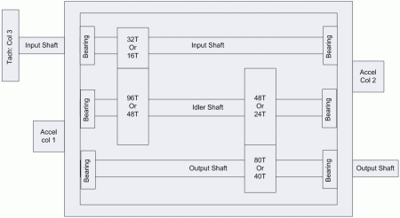
Figure 1: Schematic of the apparatus (click to enlarge).
Two geometries are used,one using a spur gears, the other using spiral cut (helical) gears. The spur geometry is:
- Input shaft: 1-Input Pinion: 32 teeth
- Idler shaft: 1st idler gear: 96 teeth
- Idler shaft: 2nd (output) idler gear: 48 teeth
- Output shaft: output pinion: 80 teeth
Thus, from input to output the gear reduction ratio is: 16/48*24/40, or 5 to 1 reduction.

Acquisition System
Endevco 10mv/g Accel, +/- 1% error, Resonance > 45KHz.
Three Channels:
- Channel 1 is the input side Accelerometer
- Channel 2 is the output side Accelerometer
- Channel 3 is the Tachometer Signal: 10 pulse per revolution
Sample Rate: 66,666.67 Samples per Second (200 KHz/3).

Bearing
MB Manufacturing ER-10K
Number of Elements: 8
Roller Element Diameter: 0.3125"
Pitch Diameter: 1.319"
Contact Angle: 0
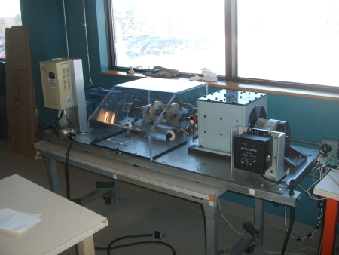
Figure 2: Overview of the apparatus (click to enlarge).
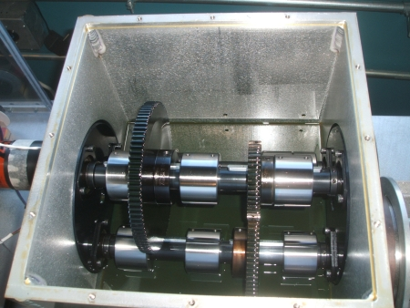
Figure 3: Inside the gearbox (click to enlarge).
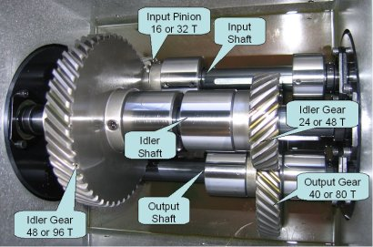
Figure 3a: Inside the gearbox detail (click to enlarge).
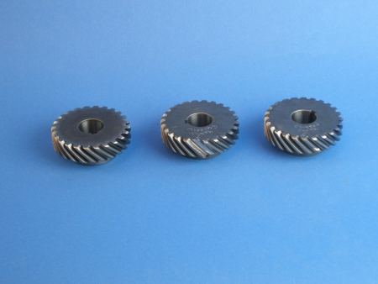
Figure 4: Example of gear faults. Left to right: normal, missing tooth, chipped tooth (click to enlarge).
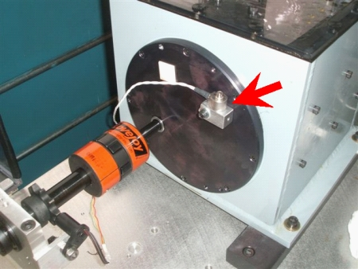
Figure 5: Location of input shaft accelerometer.
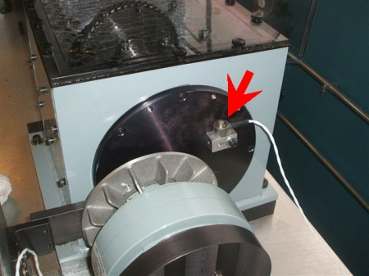
Figure 6: Location of output shaft accelerometer.
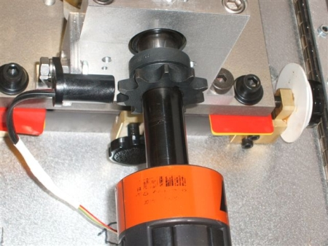
Figure 7: Detail of tachometer pickup.
A video of the system being run can be downloaded here. The change in gearbox tone is a function of the brake being applied.

Fundamentals
Some fundamental signal processing techniques and diagnostic features for gearbox components are provided below. The information provided is only intended as a brief introduction to existing domain knowledge and is NOT meant to guide the challenge participants in any way.

Time Synchronous Averaging
The common use of the synchronous averaging technique is the attenuation of both non-coherent components and the non-synchronous components, like noise in an accelerometer signal collected from rotating machinery, to negligible levels. Synchronous averaging is a fundamental process to many shaft, bearing, and gear diagnostics algorithms. A common rule of thumb is that the amount of attenuation is inversely proportional the square root of the number of averages. This rule is highly representative for the non-coherent components but is not representative for the non-synchronous terms. More information about this technique may be found in the paper:
- Hochmann, D.; Sadok, M., "Theory of synchronous averaging," Proceedings of 2004 IEEE Aerospace Conference, 2004. Vol.6, no., pp. 3636-3653 Vol.6, 6-13 March 2004 (PDF).

Accelerometer Data Analysis
Accelerometer data can be analyzed in a variety of domains like time, frequency, wavelet, etc. The most common ones are time and frequency. Some popular time domain techniques are decimating, digital filtering, averaging, and RMS. Frequency domain analysis typically comprises Fourier transform, windowing, and spectral analysis of power and amplitude. More information about processing accelerometer data can be found here.

Gearbox Component Fault Signatures
The main components of gearboxes are gears, bearings and shafts. Their common fault modes have been extensively studied in literature. The following table lists the generic locations of frequency domain features that accompany the common faults. More information can be found in the following books:
- J. M. Vance, "Rotordynamics of Turbomachinery", John Wiley & Sons, Inc., New York, USA, ISBN 0-471-80258-1, 1988.
- Keith Mobley, "Vibration Fundamentals", Elsevier, ISBN 978-0-7506-7150-7, 2001.
Common fault modes and features of a gearbox
Component | Function | Fault Modes | Features
Gear | Change rotation speed | Crack in gear | Gear natural frequency
 |  |  | Sidebands around the gear natural frequency
 |  | Cracked/broken tooth | Sidebands around gear mesh frequency
 |  | Excessive wear or clearance | Sideband spacing
Bearing | Support rotating shaft | Bearing race defect | Approximately, (n/2) x shaft speed, n is the number of balls
 |  | Excessive bearing clearance | Sub-synchronous whirl
Shaft | Transmit torque | Rotor imbalance | 1 x shaft speed
 |  | Shaft misalignment | 2 x shaft speed
 |  |  | high axial vibration
 |  | Mechanical looseness | higher harmonics of shaft speed
.

Data
Data were sampled synchronously from accelerometers mounted on both the input and output shaft retaining plates. An attached tachometer generates 10 pulses per revolution providing very accurate zero crossing information.
Data were collected at 30, 35, 40, 45 and 50 Hz shaft speed, under high and low loading. Additionally, different repeated runs are included in the data, although the run time and load were not sufficient to induce significant fault progression. There are a total of 560 samples to be classified.
Data are provided in .csv files, with three columns - the first column is input voltage, second is output voltage, and the third is tachometer.

Submitting Results
Results must be submitted as a comma separated value (CSV) file, with exactly 560 rows and 45 columns. The values must be 1 or 0, with 1 corresponding to "true" and 0 corresponding to "false". This page specifies what the values in the columns correspond to. Each row corresponds to run number, i.e., row 1 should correspond to the data in Run_1.csv, etc.
You can submit your results here.

Performance Evaluation
The goal is to minimize the Hamming distance between your results matrix and the true state of the system. For example, if the true state of the system is [1,0,0,1,0] and you submit [1,1,0,0,0,0], your score is 2. Best possible performance is indicated by a Hamming distance score of 0 and the worst score is (560x45=)25200, provided the uploaded file is correctly formatted. Only the Hamming distance score mentioned above is used to determine the final scores and ranking.

When using the data in publications, please reference the following (note the creative commons license): (cc) PHM Society, Gearbox fault detection data set, 2010

